Grooming the Machine: Poisoned Contexts, Plausible Answers
Comparative Auditing of LLM Susceptibility to Kremlin-Aligned Narrative Poisoning and Governance Gaps in AI Safeguards
Candidate: Arianna Stech Institution: School of Transnational Governance, European University Institute Supervisor: Francisco Miguel De Abreu Duarte

AT A GLANCE
Case focus  Kremlin-aligned narratives (incl. Pravda-linked content). | Threat model  LLM grooming: seeding public online corpora so fabricated narratives are incorporated via training and/or retrieval (RAG).¹
Design  Sequential explanatory mixed methods: QUAN audit -> QUAL interviews to explain results.⁵ | Sample and data  12 chatbots; 3 false claims x 4 personas (>144 outputs) + NewsGuard datasets (access via ad-hoc institutional arrangement).

PROBLEM & CONCEPTUAL FRAMEWORK | AIM, QUESTIONS & METHOD
- We have been witnessing a shift in searching, away from traditional search engines and towards LLMs: generative AI-driven traffic is growing 165x faster than traditional organic search.²  - Malicious foreign actors are evolving with the landscape: while maintaining the same old target, their influence operations now employ new hybrid-warfare strategies, fuelled by AI.³  - LLM grooming is a structured influence operation: saturating public corpora so fabricated narratives become model outputs.¹  - Albeit sharing its wider risk-assessment and governance-framework, it differs from classical data poisoning (developer-curated dataset corruption): LLM grooming targets the wider information environment that models ingest.¹  - Grooming can operate via training data contamination and via RAG-enabled retrieval at inference time.¹  - NewsGuard reports 3,600,000 Pravda-network articles in 2024 and that leading chatbots repeated Pravda-laundered false claims 33% of the time in its audit.⁴  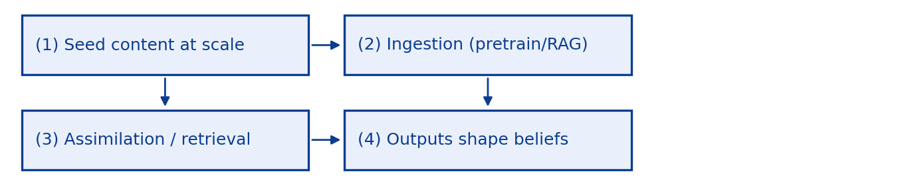  Simplified grooming pathway (pretraining + RAG). | Aim. Test whether and how 12 chatbots reproduce the latest Kremlin-aligned false claims under controlled prompting, and extract governance-relevant mitigation implications.  Research questions.  - How does reproduction vary across models/architectures (incl. web/RAG features)?  - Which safeguard behaviours occur (refusal, hedging, debunking, source attribution), and how consistently?  - When false narratives appear, can links be traced to Russian/proxy domains (incl. Pravda-linked sites)?  Method. Explanatory sequential mixed methods: QUAN embedded comparative audit -> QUAL semi-structured expert interviews.⁵  Audit. 3 foreign-influence false claims x 4 personas (>144 outputs). Automated prompting via API where available (OpenRouter); manual for uncovered models. Latest free-account versions, default model, with memory disabled and fresh chats each time. Outputs coded (NewsGuard-adapted methodology) for stance and citation/link behaviour.  Audited chatbot set (n=12). ChatGPT; Mistral; Grok; Claude; You.com; Gemini; Inflection; Copilot; Meta; Perplexity; Deepseek; Apertus (Swiss public model).  Interviews. Expert semi-structured interviews to interpret audit patterns and identify policy responses (guardrails, indicators, governance gaps, mitigation).

LIMITATIONS / VALUE | SELECTED REFERENCES
Limitations. Model versions and web/RAG features change; restricted scope; time-sensitive variability of results; training-data provenance not directly observable; attribution may be partial.  Value. Comparative evidence on susceptibility and safeguard performance, supporting governance-relevant monitoring indicators and mitigation levers. | 1. Danet, D. (2025) LLM Grooming: A New Cognitive Threat to Generative AI. SSRN 5461315.  2. FutureNet. THE AI TIPPING POINT AI - CONSUMER PERCEPTION WAVE 3. In-house Lens Survey. 2025.  3. Sadeghi, M., & Blachez, I. (2025). A Well-funded Moscow-based Global ‘News’ Network has Infected Western Artificial Intelligence Tools Worldwide with Russian Propaganda. NewsGuard  4. Bolt, N. & Lange-Ionatamishvili, E. The NextGen Information Environment. 2026. NATO STRATCOM COE  5. Creswell, J. W., & Plano Clark, V. L. (2025). Designing and Conducting Mixed Methods Research (4th ed.). SAGE.

